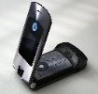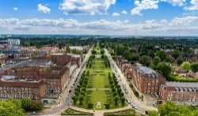

La música y tus programas preferidas y que hiciste ayer

**Jobs = what kind of job you would like to do: conditional tense**

Tenses. Negatives. Pronouns.

Present. Future. Perfect. Imperfect Tense

Justifying opinions. Writing yourself

Job vocab. Opinions. Time frames

Modal Verbs in all tenses

Connectives. Time frames. Tenses

Past. Future. Present

Role Plays

Vocab for making excuses and invitations.

Invitations

To go out

La comida y que te gusta comer para una fiesta

Voab for music, television and saying what you did yesterday

All tenses. Connectives. Opinions. Negatives

Reading and writing skills

Present. Future. Past

Technology vocab. New Adjectives.

Town and Environment

Los trabajos

¡Tú y yo!

All the grammar studied.

Tenses x5

Writing and reading using complex constructions – longer texts

‘my rights’ vocab

Adjectives – which come before noun

All the grammar studied.

Tenses x6

Writing and reading using complex constructions – longer texts

Free time vocab studied in KS3

All the grammar studied.= particular focus on reflexives and pronouns

Tenses x6

Writing and reading using complex constructions – longer texts

Relations/ Holidays vocab studied in KS3

Western Front / RAMC / FANY

Activities

Desde hace construction

Opinions.

Present. Future. Perfect. Imperfect Tense

Justifying opinions. Writing yourself

Describing activities

Deber + verb

All the grammar studied.. Food vocab

Tenses x 5

Writing and reading longer texts using complex constructions

Healthy lifestyle vocab

Work

Mis derechos

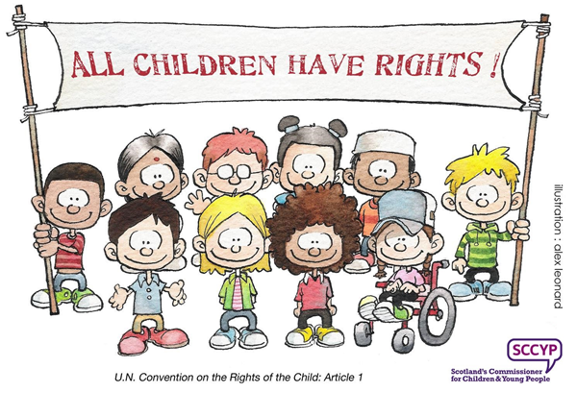

Vocab for food/some

Time frames. Negatives. Opinions.

Present Past and futute

R/L/W/S/= SENTENCES

Food vocab

Mi colegio

ar/er /ir verbs, porque

Opinions

‘ar’ verbs negatives, adjectives family members

Present = reg + irreg

Justifying Opinions

School subjects, connectives clothes. Time frames

Prepositions of place

vivir,negatives

Present Tense

Short paragraphs

Places in the town, rooms in the house, furniture

* ‘Tener’ ‘ser’ present tense
* Subject pronouns
* Colours =agreement/position
* Negatives
* ‘a’/’the’
* R/L/W/S/= SENTENCES

Adjectives, negatives, tener, ser,

Present Tense

Hair/eyes/pets/family/adjectives/countries/nationalities

R/L/W/S/= 2-3 sentences = using a range of subject pronouns for more able

Knowledge recall Exam technique

Revision & Exam Preparation

Free time and technology

|  |  |
| --- | --- |
|  | New grammer |
|  | Concepts revisted |
|  | Tenses |
|  | Skills: listening/reading/writing/speaking |
|  | Vocab Expansion |

All grammar studied

Tenses x6

Reading and writing and listening using longer texts. Spoken word practice starts

Work vocab

The preterite tense of regular and irregular verbs. Negatives

Present and future tense

Listening. Speaking. Read. And Writing

Holiday vocab. Opinions. Time frames

All grammar studied

Tenses x6

Reading and writing and listening using longer texts. Spoken word practice

School vocab

**ir + infinitive**

Present tense verbs. Negatives. Time frames

Connectives. opinions

Present and future

Longer paragrahs

Opinions. Time frames. Subordinate clauses

All grammar studied

Tenses x6

Reading and writing and listening using longer texts. Spoken word practice

Town & Environment vocab

¡Hola!

La vida sana

Mi vida

Family Relations and Holidays

Donde vives?

Mi tiempo libre

Que hiciste durante tus vacaciones

School.

7

8

9

10

11

Spanish Curriculum Map